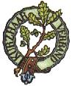
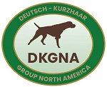
2024 DKGNA Annual Meeting/Derby/Zuchtschau Itinerary

Thursday, May 16th

6:00 – 8:00 PM Welcome Reception – The Wood River Inn
603 N. Main St., Hailey, ID 83333

Friday, May 17th

7:00 AM Meet for Derby – Valley Wide Co-op, 869 S Main St., Bellevue, ID 83313
7:30 AM Leave Valley Wide Co-op for Derby fields
8:00 AM – 2:00 PM Derby

Saturday, May 18th

9:00 AM – 12:00 PM Annual Meeting – Minnie Moore Room, of the Blaine County Community Recreation District Headquarters (BCCRD), 1050 Fox Acres Rd, Hailey, ID 83333
12:00 PM – 1:00 PM Lunch - BCCRD
1:30 PM – 4:00 PM Zuchtschau – BCCRD
5:00 PM – 6:00 PM Social Hour – The Kneadery, 260 N Leadville Ave Ketchum, ID 83340
6:00 PM – 9:00 PM Banquet/Awards/Auction – The Kneadery

